

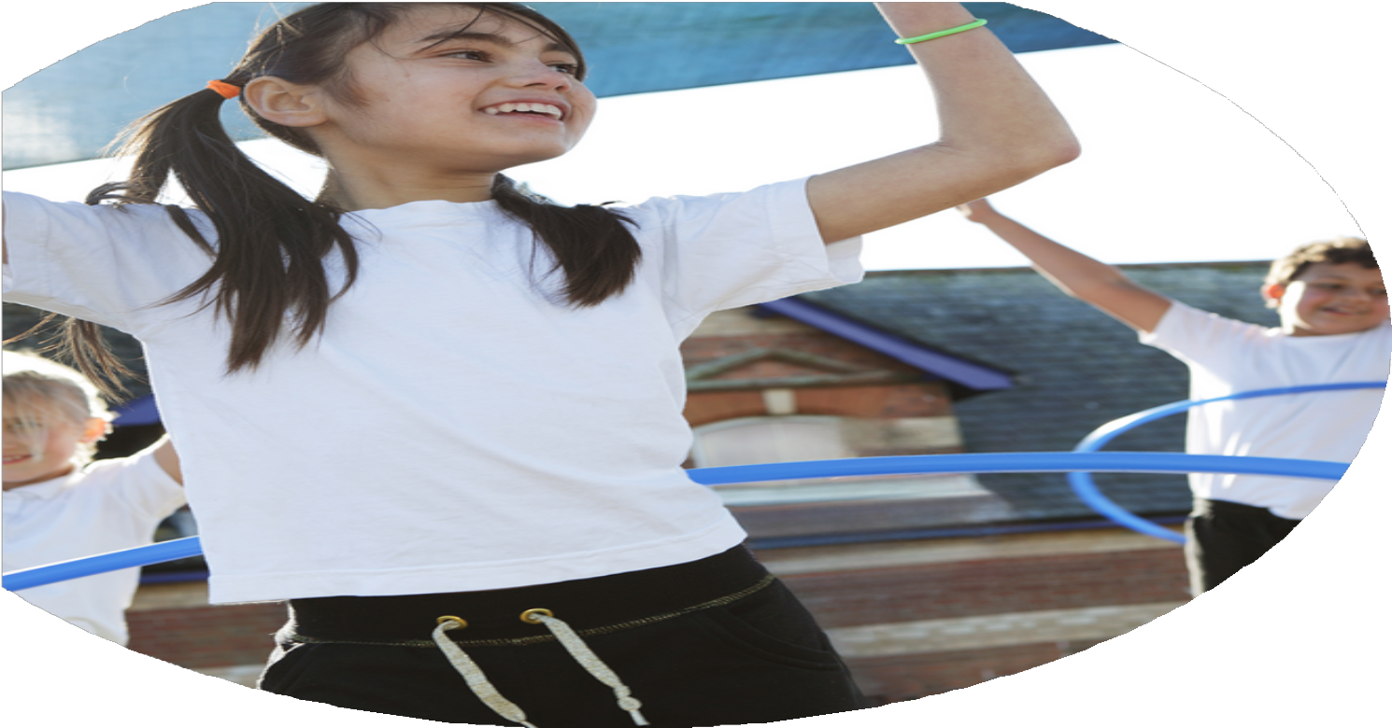
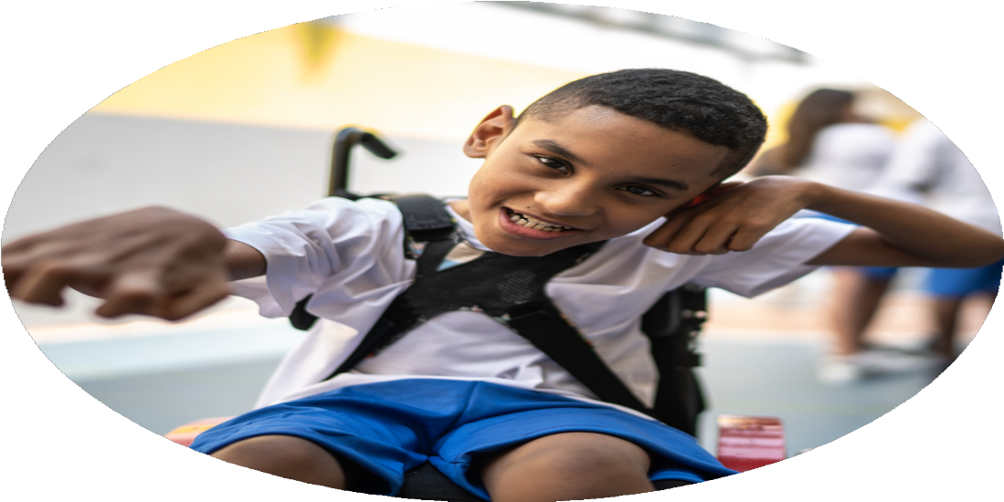




PE Funding

Evaluation Form

Commissioned by

Created by

Images courtesy of Youth Sport Trust

PE Funding Evaluation Form

It is intended that this template should be used as preparation for the completion of the statutory digital reporting tool being introduced this academic year. You can upload data (including swimming) from this template onto this platform once it becomes accessible.
Before you decide how you are going to use the funding for this academic year you should reflect and evaluate the impact of your use of the funding in 2024/25.
All spending of the funding must conform with the terms outlined in the Conditions of Grant document. The template is a working document that you can amend/update during the year.
Based on your evaluation of last year’s funding you should decide what you intend to do this academic year, how you will do it, and what impact you expect it to have.

It is important that the funding is used effectively and based on your school’s needs.
You must use the funding to make additional and sustainable improvements to the PE and sport in your school. You must develop and add to the PESSPA activities that your school already offers.

Summative digital reporting from June 2025 will continue to include swimming and water safety information therefore funding can be used to provide top-up lessons where necessary to ensure pupils meet national curriculum swimming requirements.

We recommend that you start by reflecting on the impact of current provision and reviewing your previous spend.

What went well? | How do you know? | What didn’t go well? | How do you know?
Strong links with key partners – Hartlepool Borough Council, Panathlon UK, SEND schools and Trust schools. | More children attended events/festivals – registration.  Children now attend sports session outside of school – registration. | Transport can be an issue for some parents based on their geographical location. | Parent voice.
Continued focus on opportunities for girls to take part in school sport and engage in inter-school/intra-schools’ events. · | Attendance of events are registered by schools and those running the events – Panathlon UK, Trust schools, HBC, etc. | Some events were particularly complex both physically and cognitively for some of our girls. | Staff feedback after attending events to support children
Springwell School has successfully achieved the School Games Platinum Award after achieving the School Games Gold Award for four consecutive years. | Official confirmation for the School Games – certificate and validation on the SG website.
Our extensive swimming provision ensures we go above and beyond to provide our children with the best possible opportunities to gain vital life skills – all children at Springwell will swim every week. We have continued to maximise the use of our school pool. | Children have developed and improved vital life skills as they progress through our adapted swimming programme which includes Ducklings and ASA awards. Whilst using the school pool, we have written and developed our own ‘Springwell Steps Swimming Programme’ bespoke to the needs of our children.  Registration and assessment results – children are certified as they achieve each swimming stage.
Opportunities for intra-school competitions, allowing all children to engage in a range of sports and compete against other classes. | Children have had opportunities to compete against one another in events such as Sports Day and Multi-Skills Festivals.
Strong links with schools within the Extol Trust Academy (working with fellow PESSPA Leads).  Contribute towards the successful running of our trust wide events programme. Also, running a SEND event as part of the programme. | Registration for attending each event.  Termly networking meetings and AGM.  Children’s experiences and successes are celebrated through receiving awards.

What are your plans for?  Intent | How are you going to action and achieve these plans?  Implementation
Continue to engage our least active children in a range of physical development opportunities – aligned with their EHCP, OT and/or Physiotherapy plan. | Staff will use sensory are physio equipment to support children during specific time – one: one and as part of a group.  OT/Physio plans will be implemented at this point.
To continue to provide swimming lessons for all children swim for 45 minutes every week (above and beyond the PE National Curriculum expectations), including transport to and from these lessons. | Provide all children with the opportunity to develop water confidence, ability to perform a range of strokes and experience a variety of water-based activities (depending on ability).  Children will gain vital life skills and increase the amount of physical activity.
Further opportunities for staff to complete CPD on Sensory Play and Physical Development. | Receive CPD information and opportunities, up to date information on competitions, events, initiatives, etc. SLT fully understand and support the promotion of PE, Activity and Sport and appreciate the positive impact it has on the whole school.
Continue to increase our school PE profile, by achieving the highest level possible – School Games Mark. The aim is to continue to achieve the School Games Platinum Award. | The school PESSPA programme remains focused and challenging and offers many opportunities for children to engage in a broad range of activities designed to meet their physical and sensory needs – linked to EHCP’s and PLP’S.
Address development areas in PE and increase the amount of regular physical activity children engage in. Key areas for development: SEND, SEMH regulation, sensory opportunities, work on children’s individual physiotherapy programmes.  Continue to strengthen our links with key partners (clubs). | More children attending clubs both at school and at local sports venues, strong links with key partners and regular opportunities for regulation through physical activity (planned into the school day).  Increased opportunities in a variety of sports and chance to try new exciting sports.
Introduce new sports and activities, which all children can access.  Wider sporting opportunities Outdoor and Adventurous Activities. Children will be given the opportunity to take part in Outdoor and Adventurous sports – e.g. Archery and Forrest School activities. Staff to transport children and support them during lessons/activities. | The after-school sports club offers children the opportunity to increase their participation in physical activity.  Opportunity for Teaching Assistant’s to work with PE teachers, coaches and instructors. Increase numbers of children who attend after-school sports club. The Teaching Assistant’s will benefit from working with the teachers, coaches and instructors, deepening their knowledge and skill set in PE.
To continue to strengthen our partnership with all schools within the Trust and attend a vast array of physical development opportunities. | Contribute to the running the Trust PESSPA programme by influencing the nature of the events, supporting other Trust schools and hosting a SEND event.

What impact/intended impact/sustainability are you  expecting? | How will you know? What evidence do you have or  expect to have?
Raised profile of PE, Sport and Physical Activity across the school. To continue to achieve the School Games Platinum Award. | Registers, environments (indoor/outdoor), School Games Mark portfolio of evidence, Calendar of events, social media posts, staff/pupil voice feedback, parents’ views and school website.
All pupils, regardless of need or ability, can participate in physical activity and events fully through adapted resources, differentiated tasks, and specialist approaches. To promote a sense of belonging, achievement, and equality. | Evidence of progress in ‘Physical and Sensory’ linked to EHCP’s and PLP’s, Physio plans, participation logs and registers (extra-curricular activities), social media and staff and child voice.
Staff confidently using physical activity to support sensory and emotional needs to promote a more active, movement-friendly school with PE embedded throughout the day. | Evidence for Learning – evidenced in the ‘Physical and Sensory’ and ‘Social, Emotional and Mental Health’ section, inform the future Physical Education and Development curriculum, social media, school, website, parents and child voice and participation and engagement logs (E4L).
A structured, progressive PE curriculum tailored to SEND needs (continuous development). Systems for assessing progress and tracking engagement to maintain high expectations. | E4L, PLP’s, Physio Plans, PE curriculum document, engagement motivators and profiles, record of achievement, school website, social media and meetings with parents.
- Sustainable links with local sports clubs, SEND-friendly providers, physiotherapy teams, and national school games organisations.

What impact/sustainability have you seen? | What evidence do you have?
Increased participation in a wide range of physical and sensory activities in school and within the local and regional area. | Registers, social media posts, school website, newsletter, certificates of attendance, awards and EHCP and PLP targets.
Consistently achieving the School Games Gold Mark for four consecutive years before achieving the School Games Platinum Award. | Official confirmation for the School Games – certificate and validation on the SG website. School social media, school website and newsletter.
Staff are confident when leading specific physio/physical/sensory activities. | Training logs, Physiotherapist feedback, progress seen in Pupil Learner Plans and Education, Health and Care Plans, staff/parents and pupil voice.
A wide range of our children continue to be involved in PESSPA events which promote a positive culture with school and across the Trust. | Register, school and Trust social media, staff/parents and pupil voice.
Children attend an array of local and regional events to increase participation and to compete, including SEND-specific events. | Registers, social media posts, school website, newsletter, certificates of attendance, awards and staff/parents and pupil voice.
All children access weekly swimming lessons to improve safety and awareness and to improve their skill development. | Registers, assessment and awards.

