

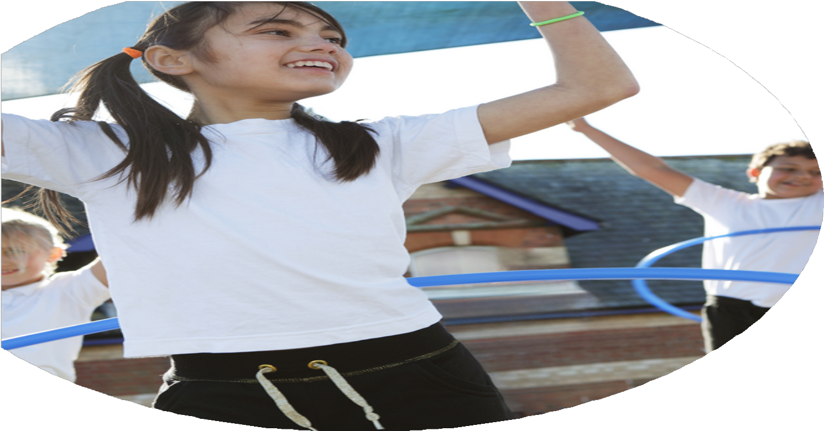
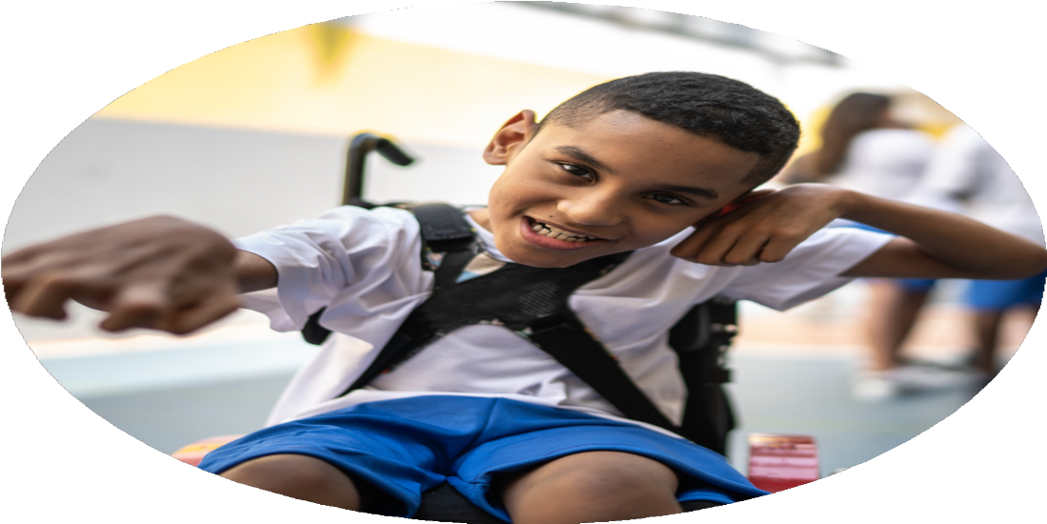




PE Funding

Evaluation Form

Commissioned by

Created by

Images courtesy of Youth Sport Trust

PE Funding Evaluation Form

It is intended that this template should be used as preparation for the completion of the statutory digital reporting tool being introduced this academic year. You can upload data (including swimming) from this template onto this platform once it becomes accessible.
Before you decide how you are going to use the funding for this academic year you should reflect and evaluate the impact of your use of the funding in 2025/26.
All spending of the funding must conform with the terms outlined in the Conditions of Grant document. The template is a working document that you can amend/update during the year.
Based on your evaluation of last year’s funding you should decide what you intend to do this academic year, how you will do it, and what impact you expect it to have.

It is important that the funding is used effectively and based on your school’s needs.
You must use the funding to make additional and sustainable improvements to the PE and sport in your school. You must develop and add to the PESSPA activities that your school already offers.

Summative digital reporting from June 2025 will continue to include swimming and water safety information therefore funding can be used to provide top-up lessons where necessary to ensure pupils meet national curriculum swimming requirements.

We recommend that you start by reflecting on the impact of current provision and reviewing your previous spend.

What went well? | How do you know? | What didn’t go well? | How do you know?
Continued to work closely with key partners – Hartlepool Borough Council, Panathlon UK, SEND schools and Trust schools. | More children attended events/festivals suitable to their individual needs – registration.  Children now attend sports sessions outside of school (HBC/Families First) – registration. | Transport can be an issue for some parents based on their geographical location. However, Families First supply transport for identified children. | Parent voice and feedback from FF/HBC.
Continued focus on opportunities for children with varying needs to take part in school sport and engage in inter-school/intra-schools’ events. · | Attendance of events are registered by schools and those running the events – Panathlon UK, Trust schools, HBC, etc. | Some events were particularly complex both physically and cognitively for some of our children. However, feedback has been welcomed, and opportunities are increasingly more accessible. | Staff feedback after attending events to support children.
Springwell School has successfully achieved the School Games Platinum Award for the second year running after achieving the School Games Gold Award for four consecutive years. | Official confirmation for the School Games – certificate and validation on the SG website.
Our extensive swimming provision ensures we go above and beyond to provide our children with the best possible opportunities to gain vital life skills – all children at Springwell will swim every week. We have continued to maximise the use of our school pool. | Children have developed and improved vital life skills as they progress through our adapted swimming programme which includes Ducklings and ASA awards. Whilst using the school pool, we have written and developed our own ‘Springwell Steps Swimming Programme’ bespoke to the needs of our children.  Registration and assessment results – children are certified as they achieve each swimming stage.
Opportunities for intra-school competitions, allowing all children to engage in a range of sports and compete against other classes. | Children have had opportunities to compete against one another in events such as Sports Day and Multi-Skills Festivals.
Strong links with schools within the Extol Trust Academy (working with fellow PESSPA Leads).  Contribute towards the successful running of our trust wide events programme. Also, running a SEND event as part of the programme. | Registration for attending each event.  Termly networking meetings and AGM.  Children’s experiences and successes are celebrated through receiving awards.
Provide Rebound Therapy sessions for pupils, particularly those with PMLD, delivered by trained and qualified staff. | Pupils have improved core strength, balance, coordination and physical wellbeing while following physiotherapy programmes.  Children Pupil Learner plans show progress and include new targets.
CPD for staff in specific areas – sensory play, Rebound and developmental movement training. | Certificate of attendance.  New programmes rolled out in school which shows progress within PLP’s.

What are your plans for?  Intent | How are you going to action and achieve these plans?  Implementation
Ensure all pupils access weekly swimming lessons or water-based activities, exceeding statutory requirements. | Design a swimming programme tailored to suit all individual learners. Children identified as being capable of accessing and engaging in a more structured swimming lesson will access Highlight (Local Swimming Centre).
Provide Rebound CPD - staff meetings and training to develop staff knowledge and confidence in delivering high-quality Rebound and improving Physical Development. | School trainers will provide training for staff in order to implement a Rebound programme designed to meet the physical and communication needs of all children during weekly sessions.

What impact/intended impact/sustainability are you  expecting? | How will you know? What evidence do you have or  expect to have?
A structured tailored Swimming programme designed to meet individual needs and support progress in swimming and communication. | E4L, PLP’s, Physio Plans, PE curriculum document, engagement motivators and profiles, record of achievement, school website and meetings with parents.
Train staff to lead Rebound sessions for identified children in school to meet their physical, sensory and communication needs. | E4L, PLP’s, Physio Plans, PE curriculum document, engagement motivators and profiles, record of achievement, school website and meetings with parents.
Staff confidently using physical activity to support sensory and emotional needs to promote a more active, movement-friendly school with PE embedded throughout the day. | Evidence for Learning – evidenced in the ‘Physical and Sensory’ and ‘Social, Emotional and Mental Health’ section, inform the future Physical Education and Development curriculum, social media, school, website, parents and child voice and participation and engagement logs (E4L).
A structured, progressive PE curriculum tailored to SEND needs (continuous development). Systems for assessing progress and tracking engagement to maintain high expectations. | E4L, PLP’s, Physio Plans, PE curriculum document, engagement motivators and profiles, record of achievement, school website, social media and meetings with parents.
Raised profile of PE, Sport and Physical Activity across the school. To continue to achieve the School Games Platinum Award. | Registers, environments (indoor/outdoor), School Games Mark portfolio of evidence, Calendar of events, social media posts, staff/pupil voice feedback, parents’ views and school website.
All pupils, regardless of need or ability, can participate in physical activity and events fully through adapted resources, differentiated tasks, and specialist approaches. To promote a sense of belonging, achievement, and equality. | Evidence of progress in ‘Physical and Sensory’ linked to EHCP’s and PLP’s, Physio plans, participation logs and registers (extra-curricular activities), social media and staff and child voice.
- Sustainable links with local sports clubs, SEND-friendly providers, physiotherapy teams, and national school games organisations.

What impact/sustainability have you seen? | What evidence do you have?
Increased participation in a wide range of physical and sensory activities in school and within the local and regional area. | Registers, social media posts, school website, newsletter, certificates of attendance, awards and EHCP and PLP targets.
Consistently achieving the School Games Gold Mark for four consecutive years before achieving the School Games Platinum Award. | Official confirmation for the School Games – certificate and validation on the SG website. School social media, school website and newsletter.
Staff are confident when leading specific physio/physical/sensory activities. | Training logs, Physiotherapist feedback, progress seen in Pupil Learner Plans and Education, Health and Care Plans, staff/parents and pupil voice.
A wide range of our children continue to be involved in PESSPA events which promote a positive culture with school and across the Trust. | Register, school and Trust social media, staff/parents and pupil voice.
Children attend an array of local and regional events to increase participation and to compete, including SEND-specific events. | Registers, social media posts, school website, newsletter, certificates of attendance, awards and staff/parents and pupil voice.
All children access weekly swimming lessons to improve safety and awareness and to improve their skill development. | Registers, assessment and awards.
Children will access weekly Rebound sessions on the trampoline designed to meet their physical, sensory and communication.

