Books: You Choose, Oi Frog, Never Tickle a Tiger, Zog, Seaside Holidays: Then and Now, Poems Out Loud!, What The Ladybird Heard at Christmas, Haunted House.
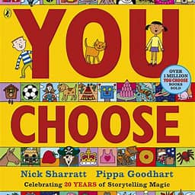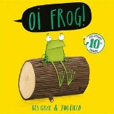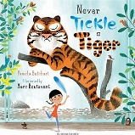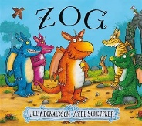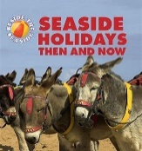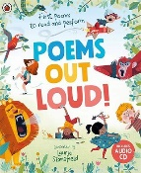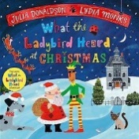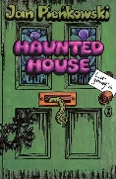
Subject | Focus | Content
Reading | Little Wandle Phonics Scheme Phases 2-5. | Daily phonics lesson at relevant phase, thrice weekly 1-1 reading session focusing on decoding, prosody and comprehension. Weekly library session. Daily book sharing with whole class.  Narrative, Poetry, Non-Fiction
Writing | Nelson Handwriting Scheme using Little Wandle letter formation guidance. Writing practice within specific Little Wandle phonics sessions. | Daily specific session and opportunities to apply throughout the day in all lessons.  Using capital letters and full stops.
Speaking and Listening | Vocabulary development – topic specific vocab.  Forming narratives and using imagination | Various opportunities to discuss to use and develop vocabulary through i.e. circle time, classroom activities, free play, peer to peer conversations. etc. Assemblies and performances. Opportunities to recount experiences and tell stories.
Maths | Match, Sort and Compare  Measure and Pattern  123  Circles and Triangles  12345  Shapes with 4 sides. | Matching objects and pictures, identifying and making sets, different ways to sort.  Compare size, mass, capacity. Explore, copy, extend and create patterns.  Find and recognize, 1 more, 1 less.  Identify, compare, shapes in the enviro and position.  Find and recognize, 1 more, 1 less.  Identify, compare, shapes in the environment and my day and night.
PSHE | Being Me in My World | All about me, How am I feeling today?, working with others and considering their feelings, being kind and having gentle hands, our rights and our responsibilities.
Science | Clothes - Materials | Naming and identifying different items of clothing, different clothing for different purposes/jobs, making a dressing up box, sorting clothing, clothing for different weather conditions and how can we wash and dry clothing.
History | What were UK seaside holidays like in the past? | Visiting a modern seaside resort and a more traditional. Classifying activities, clothing and equipment from now and the past. Exploring objects from now and the past.
Geography | Places We Enjoy | Visiting the park, beach, farm, playground. What do we do in places? How can we change these places? What do we expect to find in these places?
Music | Who Shall I Be Today? | Listen to a range of songs about animals, make animal puppets and perform the songs with them. Christmas performance and Christmas songs to sing.
Art/DT | Print | Looking at existing work that uses repeated patterns. Using a variety of materials to stamp and press on different surfaces. Creating their own patterns. Designing and creating their own t-shirt/PE bag.
PE | Sequencing Movement | Action songs. Moving to nursery rhymes with different dance styles and to show different feelings. Running and chasing games. Body part games and dances.
Computing | Algorithms and Colour Pixels | Producing a flow chart and the need for items to be ordered correctly. Decoding sheets to find the image and creating your own pixelated image.
RE | Let’s Find Out About Yom Kippur | Explore and discover the festival, select a charity and donate money, make a horn, meal to celebrate the end of fasting, what are we sorry for?



