Books: Gorilla, Smile Out Loud, You Must Bring a Hat, Lighthouse Keepers Lunch, The Seaside
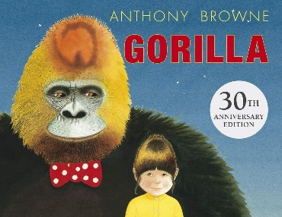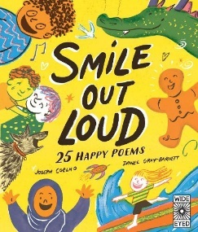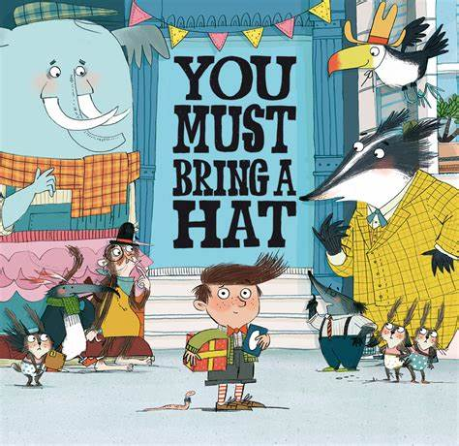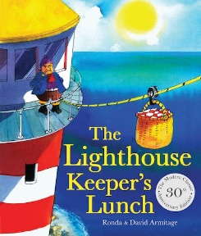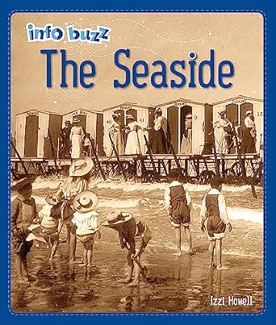
Subject | Focus | Content
Reading | Little Wandle Phonics Scheme Phases 5.  Little Wandle Spelling Scheme. | Daily phonics/spelling lesson at relevant phase, thrice weekly 1-1 reading session focusing on decoding, prosody and comprehension. Weekly library session. Daily book sharing with whole class.  Narrative, Poetry
Writing | Nelson Handwriting Scheme using Little Wandle letter formation guidance. Writing practice within specific Little Wandle phonics/spelling sessions. | Daily specific session and opportunities to apply throughout the day in all lessons.  Using punctuation with increasing accuracy, adjectives and conjunctions.
Speaking and Listening | Vocabulary development – topic specific vocab.  Forming narratives and using imagination | Various opportunities to discuss and develop vocabulary through i.e. circle time, classroom activities, free play, peer to peer conversations. etc. Assemblies and performances. Opportunities to recount experiences and tell stories.
Maths | Place Value  Addition and Subtraction  Shape | Recognising and writing numbers up to 100  Ones, tens, hundreds, partitioning  Ordering and comparing numbers  2’s, 5’s, 10’s 3’s  Number bonds within 20  Adding and subtracting 1s and 10s  Adding and subtracting 2-digit numbers
PSHE | Being in My World: Who am I and how do I fit in? | Hopes and fears, rights and responsibilities, rewards and consequences,
Science | Everyday Materials | Identifying and naming everyday materials. Comparing and grouping based on their physical properties. Carrying out simple tests.
History | How have seaside holidays changed from past to present? | What people did in at the seaside in the past, how we know this, how seasides have changed over time
Geography | Map Skills | Name, locate and identify countries and capital cities of UK and the surrounding seas. Using world maps, atlases and globes, as well as aerial images. Carrying out simple fieldwork of the school and surrounding environment.
Music | Ourselves | Singing following a melody, following instructions on how and when to sing or play an instrument, making controlled log and short sounds, changing pitch.
Art | Print | Using repeating or overlapping shapes. Creating prints using objects.
PE | Football  Gymnastics | Dribbling, ball control and small games – 1v1 and 2v2.  Explore a range of ways to travel and balance. Explore a range of apparatus – balance platforms/beams, ladders, benches, etc.
Computing | Programming | Using programmable toys to develop a sequence of instructions, follow an algorithm and debug a program
DT | Making party food | Mastering practical skills by cutting, grating or peeling ingredients, weighing ingredients and cooking ingredients
RE | Why are gifts and giving an important part of religion? | Explore gifts and why people receive them, Christian celebration of Christmas and Islamic festival of Eid al- Fir, their importance and how they are celebrated.



