Books: Dolphin Boy, A First Book of Animals, There’s a Rang-Tan in My Bedroom, The Emerald Forest, Iceberg, Arctic and Antartica
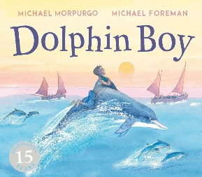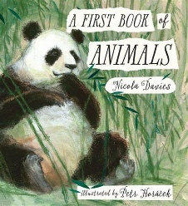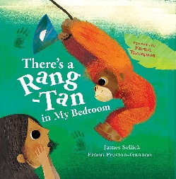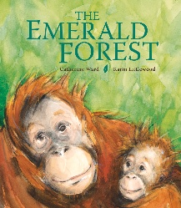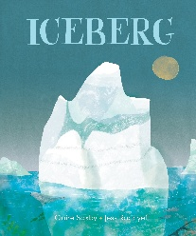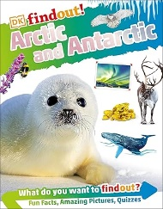
Spr 1 Wk 1-3 Spr 1 Wk 4-5 Spr 1 Wk 6-7 and Spr 2 Wk 1-2 Spr 2 Wk 3-4 Spr 2 Wk 5-6

Subject | Focus | Content
Reading | Little Wandle Phonics Scheme Phases 5.  Little Wandle Spelling Scheme. | Daily phonics/spelling lesson at relevant phase, thrice weekly 1-1 reading session focusing on decoding, prosody and comprehension. Weekly library session. Daily book sharing with whole class. Guided reading opportunities to work on higher level reading skills.  Narrative, Poetry, Non-fiction
Writing | Nelson Handwriting Scheme using Little Wandle letter formation guidance. Writing practice within specific Little Wandle phonics/spelling sessions. | Daily specific session as well as opportunities to apply writing skills throughout the day, across the curriculum.  Continuing to develop accurate use of punctuation, adjectives and conjunctions. Using adverbials and adventurous vocabulary.  Writing for purpose: Non-chronological report, diary/monologue, formal letter, persuasive advert
Speaking and Listening | Vocabulary development – topic specific vocab.  Forming narratives and using imagination | Various opportunities to discuss and develop vocabulary through i.e. circle time, classroom activities, free play, peer to peer conversations. etc. Assemblies and performances. Opportunities to recount experiences, role-play and take part in discussions.
Maths | Place Value  Addition and Subtraction  Multiplication and Division  Shape | Bronze/Silver Pathway  Adding and subtracting 1s  Adding and subtracting 2-digit numbers  Number sequences  Doubling and halving  Odd and even  One-step problems involving multiplication and division  Count in 2, 3 and 5  Multiplication and division facts for 2, 5 and 10  Grouping and sharing  Recognising and naming 2D and 3D shapes  Properties of 2D and 3D shapes  Patterns  Symmetry | Gold Pathway  Finding 10, 100 and 1000 more or less than a given number  Rounding to 10, 100 and 1000  Estimating  Negative numbers  Roman numerals  Multiplication and division facts (up to x12 tables)  Doubling and halving  Commutativity  Mental methods for multiplication and division  Formal written method for multiplication and division  Identify, describe, compare and make 2-D and 3-D shapes  Angles and lines  Symmetry
PSHE | Celebrating Differences  A World without Judgement | Bronze/Silver Pathway  Respecting similarities and differences. Anti-bullying and being unique. Exploring stereotypes and why these might be hurtful. | Gold Pathway  Breaking down barriers through inclusion and acceptance. Exploring positive attitudes and how we are unique.  Exploring our diverse communities.
Science | Seasons and Changes | In this unit, we will explore how the weather and trees change over the seasons. We will look at how daylight varies. Working scientifically, we will gather and record data
History | Kings and Queens | We will be looking into the question of What is the role of the Royal family? We will use artefacts, pictures and stories to find out about significant monarchs of the past and the role they played. We will recount changes that have occurred in our own lifetime with the change of our current monarchy.  As well as this, we will develop our chronological skills by creating our own time line.
Geography | Polar Regions | Exploring geographical similarities and differences through studying the human and physical geography of the United Kingdom in contrast to the Polar Regions (Arctic and Antarctica).  We will continue to practice our map skills to identify the location of the North and South poles.
Music | Seasons | Our topic this term is the seasons. We will focus on singing with expression and using rising and falling pitch. We will learn to sing an ostinato with Maketon signs and some Japanese songs which represent blossom.
Art | Sculpture | Using clay, we will combine shapes to create a 3D sculpture. We will practice techniques such as rolling, cutting, moulding and carving. As well as adding lines and texture using modelling tools.
PE | Basketball  Dance | In Basketball, we will use jumping, catching and dribbling techniques, and develop our attacking and defending tactics.  As part of our dance, we will work on control and awareness of space. By the end of the unit, we will be able to show contrasts (small/tall, wide/narrow) in a dance sequence. We will develop our flexibility and practice jumping and landing in a variety of ways.
Computing | iDraw  iProgram 1 | Exploring and developing skills using digital tools to create and edit graphical art.  Using algorithms and simple programming in the context of programming physical and virtual toys to perform specific actions.
DT | Exploring materials | We will demonstrate a range of joining techniques, as well as cutting and shaping. Using out Maths skills, we will measure and mark our fabric to create our final product.
RE | Judaism  Baha’i | Introduction to Judaism. Exploring the creation story, Shabbat and synagogues.  Exploring the teachings of Baha’u’llah and what Baha’i’s believe about God and the important messenger.

