Books: A Bear called Paddington , The Emperor of Absurdia, The Bear and the Piano, Walter the Wonder Snail, The Tunnel, Marvellous Vehicles, A Ticket to Kalamazoo
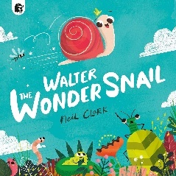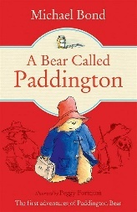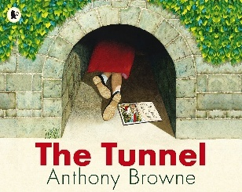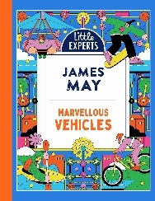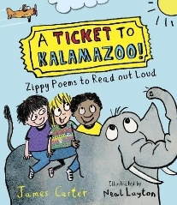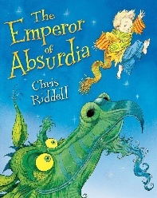
Sum 1 Wk 1-2 Sum 1 Wk 3-4 Sum 2 Wk1-3 Sum 2 Wk 4-6 Reading for pleasure linked to theme

Subject | Focus | Content
Reading | Little Wandle Spelling Scheme. | Daily phonics/spelling lesson at relevant phase, thrice weekly 1-1 reading session focusing on decoding, prosody and comprehension. Weekly library session. Daily book sharing with whole class. Guided reading opportunities to work on higher level reading skills.  Narrative, Poetry, Non-fiction
Writing | Nelson Handwriting Scheme using Little Wandle letter formation guidance. Writing practice within specific Little Wandle phonics/spelling sessions. | Daily specific session as well as opportunities to apply writing skills throughout the day, across the curriculum.  Continuing to develop accurate use of punctuation, adjectives and conjunctions. Using adverbials and adventurous vocabulary.  Writing for purpose: informal letter, journey story, explanation text, advert, poetry
Speaking and Listening | Vocabulary development – topic specific vocab.  Questioning and explanations | Various opportunities to discuss and develop vocabulary through i.e. circle time, classroom activities, free play, peer to peer conversations. etc. Assemblies and performances. Opportunities to recount experiences, role-play and take part in discussions.
Maths | Fractions  Mass, capacity and temperature  Decimals  Money  Time | Bronze/Silver Pathway  Parts and whole  Recognising and finding half, quarter and a third  Unit and non-unit fractions  Counting in fractions  Counting and comparing pence and pound  Making a pound  Finding change  Hours, minutes and seconds  Days and months  O’clock, half past quarter to and quarter past  Measure and compare mass (g and kg) and volume and capacity (ml and l)  Temperature | Gold Pathway  Comparing and ordering unit fractions  Equivalent fractions  Mixed numbers  Improper fractions  Measuring, comparing and calculating mass (g and kg) and capacity and volume (ml and l)  Tenths and hundredths  Comparing and ordering decimals  Dividing by 10 and 100  Pounds and pence  Adding, subtracting and comparing amounts of money  Finding change  Telling time to the nearest minute  Using am and pm
PSHE | Dreams and Goals  Feelings and Emotions | Bronze/Silver Pathway  Setting realistic goals and persevering when tasks are difficult.  Recognising who we work well with and working together to create an end product.  Sharing success with others. | Gold Pathway  Recognising thoughts, feelings and emotions, and the differences between those that feel good and those that don’t.  Exploring jealousy, anger and worry
Science | Plants | In this unit, we will explore a variety of common wild and garden plants, as well as identifying and describing the basic structure of a variety of common flowering plants, including trees. We will carry out investigations to work out what plants need to grow and stay healthy.
History | Transport: How have planes changed through time? | The children will investigate how and why humans learnt to fly. They will compare old and modern technology, and learn all about the Wright brothers and other pioneers of flight.
Geography | Passport to the World - comparing Hartlepool to another location | Exploring key physical and human features,  Using compass directions to describe the location of features and routes on a map.  Devising simple map which include a key using basic symbols  Learning to use simple grid references.
Music | Travel (Music Express) | Exploring patterns of physical movement in a game song and responding to a song with movement  Using steady beats and rhythms to accompany a song  Preparing and improving a performance using movement, voice and percussion, as well as using instruments expressively •  Developing our understanding notation  Songs: Tanzanian game song, Going to Town on a Bus, Simama Kaa, Our Fast Machine,
Art | Collage | Creating a collage using a combination of materials that are cut, torn and glued.  Mixing materials to create texture.
PE | Tennis  Athletics | Familiarising ourselves with the ball and racket. Practising sending and receiving skills. Developing our techniques to play a simple game of tennis.  Playing a range of games to practise our running, jumping and throwing skills.
Computing | iData  ILearn AI | Using a variety of digital tools to create pictograms, tables and graphs.  An introduction to Artificial Intelligence (AI) and how these are part of everyday life. Exploring its potential and limitations.
DT | Textiles: Fabric Bunting | Shaping textiles using templates.  Joining textiles using running stitch.  Colouring and decorating textiles
RE | Islam | Who is God to Muslims?  How important is the prophet Muhammed to Muslims?

