Fill in the missing words!
Dad | long | tail
eyes | strong | whiskers
head | said | big

“What does he look like? Tell me, _______.
Is he terribly ________ and terribly bad?”
“I can’t quite remember,” The Gruffalo _______.
Then he thought for a minute and scratched his _____.
“The Big Bad Mouse is terribly _______,
and his scaly ________ is terribly _______.
His _______ are like pools of terrible fire,
And his terrible _________ are tougher than wire.”

Read and draw!
tail
whiskers
eyes
claws
shoulder
footprints

Look and write the words!
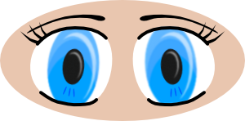 | _____________
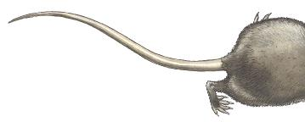 | _____________
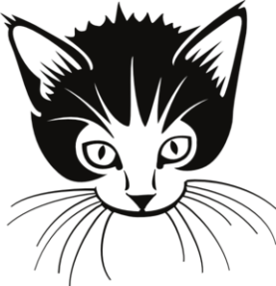 | ____________
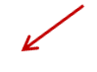  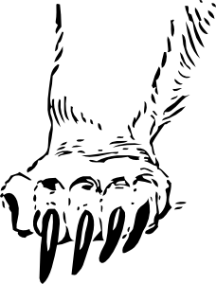 | _____________
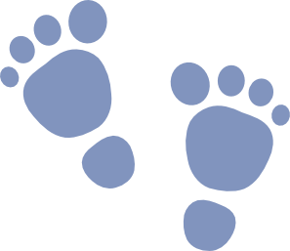 | ____________
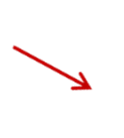   | _____________

Read and write! Which words rhyme?
bored | wild | said
long | - bad | go
house | cake | wire
see | shoulder | cave

Dad | bad
head | said
strong | long
fire | wire
snored | bored
child | wild
snow | go
mouse | house
snake | cake
tree | see
boulder | shoulder
brave | cave
Dad | bad
head | said
strong | long
fire | wire
snored | bored
child | wild
snow | go
mouse | house
snake | cake
tree | see
boulder | shoulder
brave | cave

