Books: Whatever Next, Octopants, Aliens Love Underpants, Here Come the Aliens, Monsters in Trucks
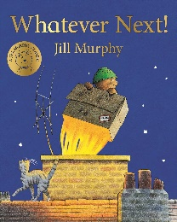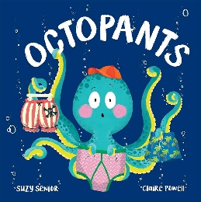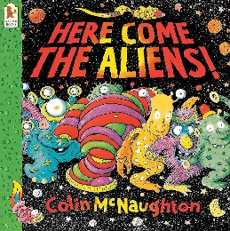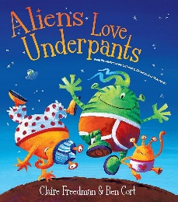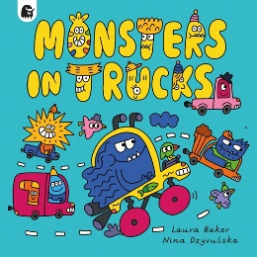

Week Beginning | Story
5/1/26 | Whatever Next
12/1/26 | Whatever Next
19/1/26 | Whatever Next
26/1/26 | Octopants
2/2/26 | Octopants
9/2/26 | Here Come the Aliens
16/2/26 | Here Come the Aliens
2/3/26 | Here Come the Aliens
9/3/26 | Aliens Love Underpants
16/3/26 | Aliens Love Underpants
23/3/26 | Monsters in Trucks
30/3/26 | Monsters in Trucks

Subject | Focus | Content
Reading | Love of Reading  Phonics | Weekly visit to the library to explore and read self chosen books with an adult and an opportunity to take self-chosen ‘love of reading’ books home to share with families.  Opportunities on a daily basis for free reading/ exploration of books within class, outdoor reading areas and the school library.  Phase 1 phonics – 5 times a week each morning: listening and remembering sounds, alliteration, rhythm and rhyme  Phase 2-4 phonics – 5 times a week each morning: letter sounds and letter identification  Reading phonics reading book at least 3 times a week.  Daily opportunity to sing new and familiar songs and nursery rhymes  Daily reading with and to children – both class stories and self-chosen books. Discussion and vocabulary development should occur around these books.  Opportunities for imaginative/ narrative/ book based play.
Writing | Lower Glitter  Mark making, Overwriting, writing of name, fine motor skills, holding writing utensils.  Upper Glitter  Mark making, letter formation, writing name, fine motor skills, holding writing utensils, independent attempts of writing words | Various opportunities to draw, write, make marks or undertake fine motor development (i.e. jigsaws, threading, dough disco, squiggle while you wiggle, pegs to paper etc…)  Various opportunities to practice letter and word writing. Daily opportunities for dough disco, fine motor activities and ‘Squiggle while you wiggle’, as well as early handwriting activities.
Speaking and Listening | Vocabulary development – Nouns, verbs, adjectives, adverbs, pronouns.  Combining words into short 2/3 word sentences.  Requesting, instructions, questions. | Various opportunities to discuss to use and develop vocabulary through i.e. circle time, classroom activities, guided play, free play etc. Assemblies and performances.
Maths | Lower Glitter  Number Songs, simple patterns, sorting and matching, colours, shape  Upper Glitter  Number songs, position, counting, numerals and value, money, mass | Copy, continue and create their own patterns.  Recognising and naming colours in a variety of contexts  Opportunities to match and sort objects which are the same.  Describe shapes in the environment and talk about the properties  Count forwards and backwards to 15 accurately using the counting principles.  Number Composition  Exploring where an object is positioned – on, under, behind, etc.  Introduce the Balance Scales. Explore what happens when we put different objects in them. Use vocabulary heavier and lighter.
PSHE | Building Independence  Developing Relationships  Communicating and Responding to Feelings  Rules and Routines | Children will be given time to develop their independence with eating, drinking, dressing and toileting which are all essential life skills. They will be provided with play opportunities, interaction with others and time to process and follow routines and instructions.
Science | Houses and Homes | Children will look at different types of homes and the different parts of a house.  Children will explore where they live and be able to answer simple questions about their house.  Children will sort household items in the correct rooms.  Children will visit the local area to look at different types of houses, including their own.  Children will build and make models of homes.
History | Inventors: What inventions can I find in my house? | Children will explore school to look for inventions – i.e., computer, lights, washing machine, toilet, fridge.  Children will use various technology e.g. remote control for a TV, a phone  Children will match up rooms with relevant inventions  Children will make a simple food item using technology  Children will sort and match old inventions with present say inventions.  Children will develop some understanding of how inventions were different in the past to now.
Geography | Buildings in Town | Children will visit everyday places within the Hartlepool and the features and properties of these.  Children will draw or make representations of everyday places in Hartlepool.  Children will look at and talk about photos of some of these places and how they’ve changed.
Music | 5 little men in a flying saucer  We’re going to the moon.  Plus songs that the class enjoys.  Instruments- making own | Children will listen to songs and join in with the actions and rhymes, including learning the Makaton signs.  Children will explore singing loudly and quietly.  Children will explore a range of instruments and play ‘guess the instruments’  Children will create their own instrument
Art/DT | Weaving | Children will explore the story, ‘Extra Yarn’ by Mac Barnett.  Children will visit a wool shop and collect samples of different colour and types of wool.  Children will explore different materials, using all the senses to investigate them.  Children will make simple weaving patterns which express ideas.
PE | Moving to Music | Children will explore and experience a range of things to push, as well as practising filling and carrying.  Children will be given opportunities to move in different ways, including over, under and through.  Children will develop their independence getting dressed and undressed.  Children will use a variety of equipment, including sticks, moulds, rollers, boxes, ladders and barrels.
Computing |  | Children in Lower Glitter will encounter, experience and explore a range of technology that is used in their environment; at home, at school and in the community. The children will have the opportunities to play and explore a range of cause and effect toys, participate in active learning and begin to create and think creatively.  - Children will have opportunities to make selections in order to explore and access content  - Children will have opportunities to explore ways of making sounds and listening to sounds using toys, simple apps and devices e.g. musical mats, microphones, voice changing horns etc.  - Children will have opportunities to experience and explore water e.g. washing, cleaning, pouring into different size containers and transporting water from one place to another.
RE | Buddhism/ Wesak/ Vesak  Easter | Buddhism  Children will explore Buddhism resources and what it means to be Buddhist.  Children will cook and eat vegetarian foods from Buddhist countries.  Children will take part in Buddhist art including lotus flower art, paper lanterns and dharma chakra making.  Children will listen to Buddhist chants and play along with instruments.  Easter  Children will explore a sensory Easter Story in class and an Easter story in church.  Children will sing, sign or play along to Easter songs.  Children will experience traditional Easter food.  Children will make Easter decorations and cards, as well as other Easter art



