Books: Bear Sees Colours, Elmer, Wow! Said the Owl, We Planted a Pumpkin, The quiet little Firework, Which Food Will You Choose?, How to catch a Rainbow, Jesus’s Christmas Party.
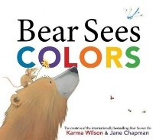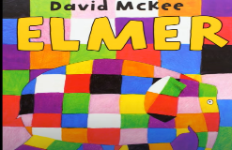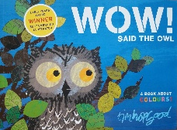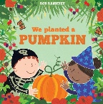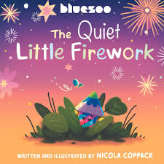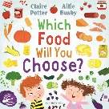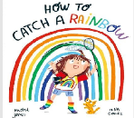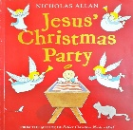

Week Beginning | Story
1/9/25 | Bear sees Colours
8/9/25 | Bear sees Colours
15/9/25 | Bear sees Colours
22/9/25 | Elmer
29/9/25 | Elmer
6/10/25 | Wow! Said the Owl
13/10/25 | Wow! Said the Owl
20/10/25 | We Planted a Pumpkin (Halloween)
3/11/25 | The Quiet Little Firework (Bonfire Night)
10/11/25 | Which food will you choose?
17/11/25 | Which food will you choose?
24/11/25 | How to Catch a Rainbow
1/12/25 | How to Catch a Rainbow
8/12/25 | Jesus’s Christmas Party
15/12/25 | Jesus’s Christmas Party

Subject | Focus | Content
Reading | Love of Reading  Phonics | Weekly visit to the School library to explore and read self chosen books with an adult. Choose a book from the Library to read with Parents at Home. Fortnightly visit to Throston Library for Story and Music. Rhythm and Rhyme session.  Daily opportunities to access classroom and outdoor reading areas.  Phase 1 phonics – Little Wandle: listening and remembering sounds, alliteration, rhythm and rhyme  Phase 2 phonics – Little Wandle: letter sounds and letter identification  Daily opportunity to sing new and familiar songs and nursery rhymes
Writing | Mark making, Overwriting, writing of name, fine motor skills, holding writing utensils. | Daily opportunities to draw, write, make marks or undertake fine motor development (i.e. jigsaws, threading, dough disco, squiggle while you wiggle, pegs to paper etc…)
Speaking and Listening | Vocabulary development – Nouns, verbs, adjectives, adverbs, pronouns.  Combining words into short 2/3 word sentences.  Requesting, instructions, questions. | Various opportunities to discuss, to use and develop vocabulary through i.e. circle time, classroom activities, guided play, free play etc. Assemblies and performances.  Use of PECS during snack-time, PECS in the pool, literacy stories and other specific activities.  Learning weekly Makaton signs for key vocabulary in Stories and Topic work.
Maths | Number Songs, counting, numerals and value, colours, mathematical language, matching, weight, length and height  Join | Joining in with number rhymes and rote counting to 10, forwards and back.  Recognising numerals 1-5, counting up to 5 objects reliably, begin to use one to one correspondence, make sets of objects up to 5, begin to demonstrate an understanding of more.  Sorting objects, build using 3D shapes, begin to construct for extended periods of time.  Identifying representations of 1, 2 and 3. Counting to find out how many and making their own collection of 1, 2 or 3 objects.  Matching number names to quantities and numerals.  Recognising and naming colours in a variety of contexts (in Nature and in the Environment)  Making weight comparisons (heavy and light) and using balance scales.  Exploring and matching objects which are the same.  Begin to use language related to length and height.
PSHE | Independence | Children will be given time to develop their independence with eating, drinking, dressing and toileting which are all essential life skills. They will be provided with play opportunities, interaction with others and time to process and follow routines and instructions.
Science | Light and Sound Toys | Children will explore and play with a range of toys that produce light and sound.  Children will use dark environments (light and sound room, dark sensory tents, dens) and use torches, fibre optic wands, glow sticks, bicycle lights, fairy lights, lanterns etc to create light.  Children will use the UV lights in light and sound room with neon coloured ribbon sticks/materials to explore.  Children will explore the ways in which they produce light and sound e.g. look where the light is coming from and what buttons need to be pressed to create the light and tun on/off sounds.
History | Memory of Events in Everyday Life | Children will begin to remember how and where to hang up coats or other personal items.  Children will begin to show recognition of very recent past events.  Children will begin to communicate about activities and events in the past.
Geography | Gardens/ Seasons | Children will visit Allotments and gardens across the term and look at flowers of different colours.  Children will visit places with wildflowers or floral displays in September and revisit the same places and see how they change over the term as the seasons change.  Children will sort summer and winter pictures.
Music | I Can Sing a Rainbow  Christmas performance, plus songs that the class enjoys.  Instruments- scrapers | Listen to the song.  Children will join in with the actions and rhymes and begin to learn the signs.  Children will experience singing loudly and quietly.  Children will explore instruments and then experience playing then stop, then repeat and stop for second time.  Children to play guess the instruments - in front of children then progress to hidden instruments.  Children to explore, experience and participate in the Christmas songs/performance
Art/DT | Paint | Children to visit the Art Gallery to focus on how artwork using paint is used. Start to make marks intentionally.  Children to explore paint, using fingers and other parts of their bodies as well as brushes and other tools.  Children to express ideas and feelings through making marks, and sometimes give a meaning to the marks they make.  Children can create rainbows, feet and hand prints, seasonal trees, flowers etc. using a range of tools to explore paint and pattern making etc. Explore painting on different surfaces e.g. paper, pavement, trees, rocks etc.  Children to turn stones into animals using paint (bees, ladybirds, fish).  Children to hide decorative rocks for others to find in the local park.  Children to explore colour and colour mixing.
PE | Climbing and Balancing | Children will explore and experience a range of balls by pushing and rolling.  Children will explore, experience and use balloons, streamers and materials to throw in the air.  Children will roll, bowl and throw a range of objects to hit a target – cause and effect activities.  Children will experience and explore a range of games that involve throwing and rolling objects.
Computing |  | Children in Lower Glitter will encounter, experience and explore a range of technology that is used in their environment; at home, at school and in the community. The children will have the opportunities to play and explore a range of cause and effect toys, participate in active learning and begin to create and think creatively.  - Children will have opportunities to make selections in order to explore and access content  - Children will have opportunities to explore ways of making sounds and listening to sounds using toys, simple apps and devices e.g. musical mats, microphones, voice changing horns etc.  - Children will have opportunities to experience and explore water e.g. washing, cleaning, pouring into different size containers and transporting water from one place to another.
RE | Rites of Passage  Christmas | Children will explore Rites of passage in a range of world religions other than birth and marriage and the art, music, food, ritual movement and costumes associated with these i.e. Bar/ Bat Mitzvah, confirmation, Shinbyu, Upunaya etc.  Christmas  Children will explore a sensory Nativity Story in class, a Nativity story in church, singing, signing or playing along to Christmas hymns.  Children will explore and experience Christmas Dinner/ Traditional Christmas foods, making Christmas decorations for trees in the church, school and/or home.  Children to experience sensory play with Christmas decorations, snow, Christmas foods/ spices, making Christmas cards.



