Books: 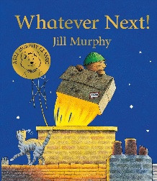 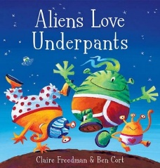 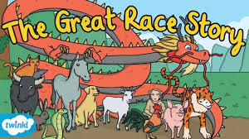 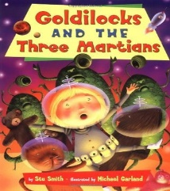 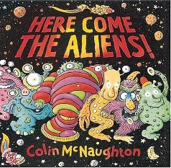 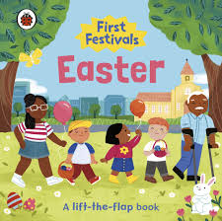

Week Beginning | Story
05/01/26 | Whatever Next
12/01/26 | Whatever Next
19/01/26 | Whatever Next
26/01/26 | Aliens love Underpants
02/02/26 | Aliens love Underpants
09/02/26 | Aliens love Underpants
16/02/26 | Chinese New Year Story – The Great Race (Class assembly)
02/03/26 | Goldilocks and the 3 Martians
09/03/26 | Goldilocks and the 3 Martians
16/03/26 | Here Come the Aliens
23/03/26 | Here Come the Aliens
30/03/26 | First Festivals Easter

Subject | Focus | Content
Reading | Love of Reading  Phonics | Weekly Sensory story with the opportunity to explore the props and learn the Makaton signs for the key vocabulary.  Answering questions about the class story using communicating print symbols.  Weekly visit to the School Library to explore and read self-chosen books with an adult. Choose a book to read with Parents at Home. Fortnightly visit to Throston Library for Story and Music. Rhythm and Rhyme session.  Daily opportunities to access classroom and outdoor reading areas.  Phase 1 phonics – Little Wandle: listening and remembering sounds, alliteration, rhythm and rhyme  Phase 2 phonics – Little Wandle: letter sounds and letter identification  Daily opportunity to sing new and familiar songs and nursery rhymes.
Writing | Mark making, Overwriting, writing of name, fine motor skills, holding writing utensils. | Daily opportunities to draw, write, make marks or undertake fine motor skills (i.e. jigsaws, threading, dough disco, squiggle while you wiggle, pegs to paper etc…)
Speaking and Listening | Vocabulary development – Nouns, verbs, adjectives,\zs\ pronouns.  Combining words into short 2/3 word sentences.  Requesting, instructions, questions. | Various opportunities to discuss, to use and develop vocabulary through i.e. circle time, classroom activities, guided play, free play etc. Assemblies and performances.  Use of PECS during snack-time, PECS in the pool, literacy stories and other specific activities.  Learning weekly Makaton signs for key vocabulary in Stories and Topic work.
Maths | Number Songs, counting, numerals and value, patterns, matching, shapes, outdoor maths, position, mass | Learn a weekly number song and explore the props.  Join in with number rhymes and rote counting to 10, forwards and back.  Recognise numerals 1-5, counting up to 5 objects reliably, begin to use one to one correspondence, make sets of objects up to 5, begin to demonstrate an understanding of more. Look for numbers in the outside environment.  Identifying representations of 1, 2 and 3. Counting to find out how many and making their own collection of 1, 2 or 3 objects.  Matching number names to quantities and numerals (up to 10)  Copy, continue and create their own patterns.  Notice and describe shapes in the environment and talk about the properties using words such as ‘straight/flat/round/ curved’.  Place objects on, under, in and out of containers.  Introduce the Balance Scales Explore what happens when children put different objects in them. They hear the words heavier and lighter.
PSHE | Independence | Children will be given time to develop their independence with eating, drinking, dressing and toileting which are all essential life skills. They will be provided with play opportunities, interaction with others and time to process and follow routines and instructions.
Science | Building and stacking with different materials | Children will explore and play with a range of construction materials e.g. card board boxes, different sized blocks, toy bricks etc. They will handle and arrange bricks/blocks on the floor and around themselves.  Experience playing in a home corner or small world home play. Can they explore different features of a house and related materials e.g. Fabrics for roof (blankets, fleece etc), materials for windows e.g. plastic acetate sheets, laminated sheets). Allow the children to select for doors, roof, windows for their house/den.
History | Memory of Events in Everyday Life | Children will begin to remember how and where to hang up coats or other personal items.  Children will begin to show recognition of very recent past events.  Children will begin to communicate about activities and events in the past.
Geography | Buildings in Town | Visit everyday places within the town – i.e. Supermarkets, restaurant, Middleton Grange, B and M, Home Bargains, Town Library, Hartlepool college.  Talk about the features and properties of the things you see along the way.  Look at and talk about photos of some of these places both before and after you’ve been.  Sort or classify things you find on your walks (i.e. things bought or found in shops)
Music | 5 little men in a flying saucer  We’re going to the moon.  Instruments that you bang | Listen to the songs and join in with the actions and rhymes. Learn the signs. Sing loudly and quietly.  Explore a range of instruments that you play by banging eg drum.  Children guess the instrument that is hidden by listening to the sound.  Learn songs related to Easter.
Art/DT | Weaving | Read the story, ‘Extra Yarn’ by Mac Barnett.  Visit a wool shop and collect samples of different colour and types of wool.  Explore different materials, using all their senses to investigate them. Make simple weaving patterns which express their ideas. Using paper strips, shape templates, different materials and then wool. Encourage the children to look at patterns in colours and in the weave itself.  Children will understand vocabulary and what it means to go, ‘Over’ and ‘under’.
PE | Moving | The children will develop their gross motor skills in soft play, rebound etc, playgrounds, swings etc.  They will have the opportunity to move over, under and through when using apparatus in the hall and outside and places we visit eg Imagination Village  Moving in different ways:- Turning and twisting, rolling, jumping
Computing |  | Children in Lower Glitter will encounter, experience and explore a range of technology that is used in their environment; at home, at school and in the community. The children will have the opportunities to play and explore a range of cause and effect toys, participate in active learning and begin to create and think creatively.  - Children will have opportunities to make selections in order to explore and access content  - Children will have opportunities to explore ways of making sounds and listening to sounds using toys, simple apps and devices e.g. musical mats, microphones, voice changing horns etc.  - Children will have opportunities to experience and explore water e.g. washing, cleaning, pouring into different size containers and transporting water from one place to another.
RE | Buddhism  Easter | Explore Buddhist resources on a Buddhist sensory tray (i.e. statues of Buddha, temples, flowers etc.)  Explore, cook and eat vegetarian foods from Buddhist countries.  Experience wearing Buddhist Clothes (white and orange robes)  Listen to Buddhist chants – play along with instruments.  Make things for other people/ classes and give it to them to make them happy.  Help or be nice to people that are sad.  Smell/ burn incense or joss sticks.  Let off party poppers (fireworks or confetti cannons)  The children will experience Buddhist art e.g Vesak – lotus flower art, Paper lanterns, Tree of kindness,  Natural patterns and Handprint heart – Dharma Chakra making  Easter  Listen to the Sensory easter Story in class and in Church.  Experience Singing, signing or playing along to religious Easter songs.  Make and taste Traditional Easter foods i.e. hot cross buns, Easter nests, Easter eggs etc.  Make Easter Crafts and cards.



