Books: 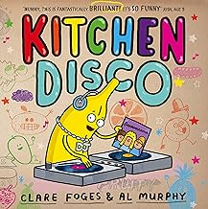 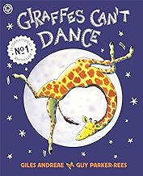 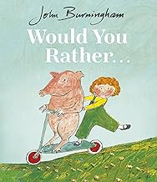 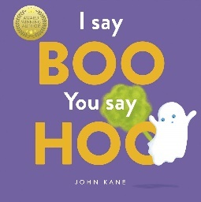 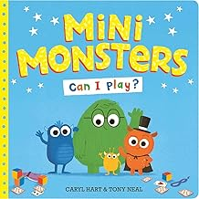 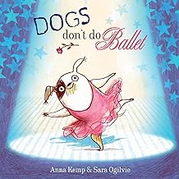 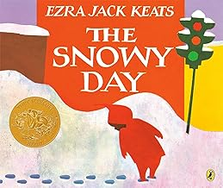
Subject | Focus | Content
Reading | Little Wandle Phase 2 and 3 | Guided reading sessions three times a week using our decodable phonics books.  Love of reading with library books, a love of reading book to be taken home each week.  Class stories.  Free choice reading.
Writing | Mark making, Overwriting, letter formation linked to Little Wandle, fine motor skills, holding writing utensils. Dough Disco | Various opportunities to draw, write, make marks or undertake fine motor development (i.e. jigsaws, threading pin pictures etc.) Formal handwriting sessions, Nelson scheme, linked to the Little Wandle mantras.
Speaking and Listening | Vocabulary development – Nouns, verbs, adjectives, adverbs, pronouns.  Combining words into short sentences.  Requesting, instructions, questions. | Various opportunities to discuss to use and develop vocabulary through i.e. circle time, classroom activities, guided play, free play etc. Assemblies and performances.
Maths | Number Songs  Counting Numerals and Values  Sequencing  Measure - Length | Children to sing number songs : 5 Little Monkeys jumping on a Bed, 5 Currant Buns, 5 Little Men in a flying saucer, 5 fat sauages.  Counting objects – real and pictorial up to 5/10 and beyond if appropriate.  Number recognition up to 10 and beyond.  Adding one and taking one away practically  More and less in real life situations  1 to 1 correspondence in counting  Sequencing pictures from familiar stories and rhymes as well as daily routines.  Exploring tall and short and long and short through practical activities.  Comparing heights of objects.
PSHE | Jigsaw – Being Me in my world lessons | Calm me to start the lessons, then 6 lessons.  - Who.. Me?  - How am I feeling today?  - Being at School  - Gentle Hands  - 5 Our Rights – School Charter  - Our Responsibilities  Turn-taking, sharing, independence and self -help skills through daily classroom activities and routines.
Science | Sorting: categorizing and talking about dry materials. | Observe a range of different materials and talk about what they can touch and see.  Sort materials into categories -rough/smooth/stretchy/non-stretchy.  Make preferences about different materials and begin to record these preferences.  Make an interactive fabric display.  Test fabric strengths
History | Having Fun: What entertainment did my parents, grandparents and people from Hartlepool enjoy in the past? | Explore old and new toys, look at pictures of old toys.  Visit entertainment places in Hartlepool – Mill House, Seaton seafront, Headland paddling pool.  Watch and talk about a Punch and Judy Show  Dance to old Music and play old instruments.  Watch old cartoons  Look at pictures of Hartlepool in the past.
Geography | School Environment | Following instructions to move around school.  Make a classroom plan  Draw a simple map of table with a mat – or use pictures to make a pictorial map.  How can we make our school better? – go litter picking outside, tidy up classroom.
Music | Disney songs – children’s favourites  Keyboards  Christmas Performance | Ask the children about their favourite Disney songs. Make a list and play, children can sing and dance along to the songs.  Children to explore toy keyboards and instruments.  Make their own compositions using symbols/pictures to make a tune.  Practice song/actions/dance for Christmas performance.
Art/DT | Printing | Look at Paul Klee artwork and look at the shapes in the pictures.  Print with shapes, vegetables, various different objects.  Explore printing on different materials – paper, fabric and a plain bag.
PE | Movement Patterns  Weekly swimming sessions | Action Songs in Class as part of rhyme time daily.  Explore Parachute with games and songs  Explore streamers  Play simple turn taking games with beanbags, cones, balls and hoops
Computing | Making a video/sound recording/taking photograph. | Children to practice taking a photograph, video or sound recording whilst acting out stories with props etc.
RE | Christmas | Read some different stories about the Christmas story – A very Noisy Christmas, Follow the Sta,.First festivals- Christmas  Make Cards.  Visit St. Hild’s Church – tree decorations.  Make a paper tube Nativity scene of Mary, Joseph and 3 wise men.  Salt dough nativity handprint  Stained glass window.



