31st March 2020

Dear Parents/ Carers,

The government has announced today an e-voucher/e-gift card scheme for pupils who are eligible for benefits-related free school meals. All schools are awaiting further information on the scheme so that we can roll the programme out.

The e-vouchers/e-gift cards are for term time only and we are working through the detail as we receive the information. Our plan is to continue as we have been, offering packed lunches, until after the Easter holidays, but if we can, we will claim your e-voucher/e-gift card this week.

For the next 3 weeks we will continue to provide FSM’s as we have been, so please continue to come into school to collect your FSM. We will inform you of further information as soon as we have it.

Once we have established how to claim the vouchers we will need to distribute them electronically, please send your email address to fsc.springwell@school.hartlepool.gov.uk if you think you will be entitled to a voucher.

For more information please see the following guidance -
https://www.gov.uk/government/publications/covid-19-free-school-meals-guidance/covid-19-free-school-meals-guidance-for-schools

Yours sincerely
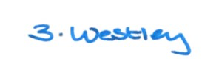

Zoe Westley

