Books: 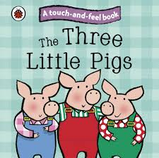 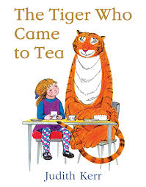 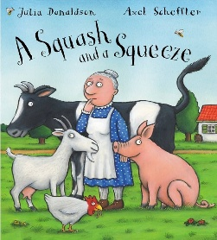 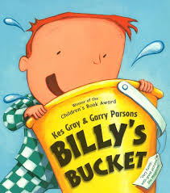 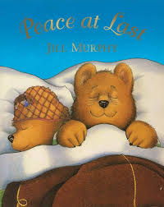

Week Beginning | Story
20/04/26 | The Three Little Pigs
27/04/26 | The Three little Pigs
04/05/26 | The Tiger that came to Tea
11/05/26 | The Tiger that came to Tea
18/05/26 | The Tiger that came to Tea
01/06/26 | A Squash and a Squeeze
08/06/26 | A Squash and a Squeeze
15/06/26 | Billy’s Bucket
22/06/26 | Billy’s Bucket
29/06/26 | Billy’s Bucket
06/07/26 | Peace at Last
13/07/26 | Peace at Last

Subject | Focus | Content
Reading | Love of Reading  Phonics | Weekly Sensory story with the opportunity to explore the props and learn the Makaton signs for the key vocabulary.  Answering questions about the class story using communicating print symbols.  Weekly visit to the School Library to explore and read self-chosen books with an adult. Choose a book to read with Parents at Home. Fortnightly visit to Throston Library for Story and Music. Rhythm and Rhyme session.  Daily opportunities to access classroom and outdoor reading areas.  Phase 1 phonics – Little Wandle: listening and remembering sounds, alliteration and rhyme time.  Phase 2 phonics – Little Wandle: letter sounds and letter identification  Daily opportunity to sing new and familiar songs and nursery rhymes.
Writing | Mark making, Overwriting, writing of name, fine motor skills, holding writing utensils. | Daily opportunities to draw, write, make marks or undertake fine motor skills (i.e. jigsaws, threading, dough disco, scarf movements, squiggle while you wiggle, pegs to paper etc)
Speaking and Listening | Vocabulary development – Nouns, verbs, adjectives,\zs\ pronouns.  Combining words into short 2/3 word sentences.  Requesting, instructions, questions. | Various opportunities to discuss, to use and develop vocabulary through i.e. circle time, classroom activities, guided play, free play etc. Assemblies and performances.  Use of PECS during snack-time, PECS in the pool, literacy stories and other specific activities.  Learning weekly Makaton signs for key vocabulary in Stories and Topic work.
Maths | Number Songs, counting, numerals and value, patterns, matching, shapes, outdoor maths, position, mass | Learn a weekly number song and explore the props.  Join in with number rhymes and rote counting to 10, forwards and back.  Recognise numerals 1-10 counting up to 5 objects reliably, begin to use one to one correspondence, make sets of objects up to 5, begin to demonstrate an understanding of more. Look for numbers in the outside environment.  Identifying representations of 1, 2 and 3. Counting to find out how many and making their own collection of 1, 2 or 3 objects.  Matching number names to quantities and numerals (up to 10)  Copy, continue and create their own patterns. Encourage the children to say the pattern out loud with an adult  Compare and order objects according to size. Learn the vocabulary ‘big, little, small, large, tall and short to describe objects.  Learn the vocabulary ‘in, on and under and follow instructions to place objects in these positions.  Encourage children to build on their understanding of full and empty. The children will be given the opportunity to explore capacity with different materials such as water, sand, rice and loose parts and will be introduced to the vocabulary ‘half full’.
PSHE | Independence | Children will be given time to develop their independence with eating, drinking, dressing and toileting which are all essential life skills. They will be provided with play opportunities, interaction with others and time to process and follow routines and instructions.
Science | Exploring Water | Allow the children to undertake as many water exploration activities as possible e.g: Observe activity in water trays (attention time) watching as water is squirted from plastic syringes, water guns. Water play using toys, water wheels, different shaped containers, water bombs, different coloured water using food colouring.  Making bubbles using resources that make big, small and no bubbles when they are squeezed whilst under the water. Exploring water by splashing, sprinkling, pouring, scooping and stirring in different environments outdoors, puddles, hydro pool etc
History | Memory of Events in Everyday Life | Children will begin to remember how and where to hang up coats or other personal items.  Children will begin to show recognition of very recent past events.  Children will begin to communicate about activities and events in the past (show children photos of recent lessons/activities in class)
Geography | Houses and Homes | Visit children’s homes – do they show recognition?  Look at houses and homes across Hartlepool – can they explore or comment upon these? Can they answer simple questions about houses and homes? Can they pick out a picture of their home? Can they engage in a home corner or a kitchen corner? Can they engage in small world home play? Can they explore household items (i.e. pillows, keys, cooking utensils etc.)? Can they build homes with blocks etc. Can they sort houses and homes? Can they draw their home?
Music | 10 Green Bottles  Ayelevi – Ghanian song -youtube or song on Music Express  Singing Hands Summer songs  Instruments – drums | Listen to the songs and join in with the actions and rhymes. Learn the signs. Sing loudly and quietly.  Dance/move to Ayelevi.  Play own instruments to Ayelevi.  Children to watch a range of African music on Youtube -drumming  Children to explore drums – large/small and make own from found materials – tub/box/metal tin and card.  Children guess the instrument that is hidden by listening to the sound.
Art/DT | Sculpture (Junk Modelling) | Visit parks, beaches and shops and collect a wide range of found materials (‘junk’) e.g. soft wood, card, offcuts of fabrics and materials with different textures. Encourage young children to explore materials/ resources finding out what they are/what they can do and decide how they want to use them.  Stimulate young children’s interest in modelling. Read the story of the, ‘Three Little Pigs’ recreate their houses using straw, twigs and sand for their roof using glue as an adhesive.  Children may have considered what they can do with different materials. They will have made simple models which express their ideas.  Children will have explored different materials, using all their senses to investigate them.  Children to use natural materials to create simple models of the Little Pigs Houses.
PE | Running | Use props to walk. Pushing, walking with trikes and buggies. Moving in different ways. Exploring different environment – spaces. Engaging in play-based activities with adults.  Will be able to show understanding of running fast and slow by responding to verbal/non-verbal instruction (pecs).
Computing |  | Children in Lower Glitter will encounter, experience and explore a range of technology that is used in their environment; at home, at school and in the community. The children will have the opportunities to play and explore a range of cause and effect toys, participate in active learning and begin to create and think creatively.  - Children will have opportunities to make selections in order to explore and access content  - Children will have opportunities to explore ways of making sounds and listening to sounds using toys, simple apps and devices e.g. musical mats, microphones, voice changing horns etc.  - Children will have opportunities to experience and explore water e.g. washing, cleaning, pouring into different size containers and transporting water from one place to another.
RE | Weddings in different religions around the world | Role play Weddings from different religious traditions (i.e. catholic, Sikh, Hindu, Muslim etc.) from around the world. Look at pictures of children’s families getting married or at weddings. Experience music, dance and food from weddings of different religions.  Read Wedding Stories e.g. ‘Peppa goes to a Wedding’.


